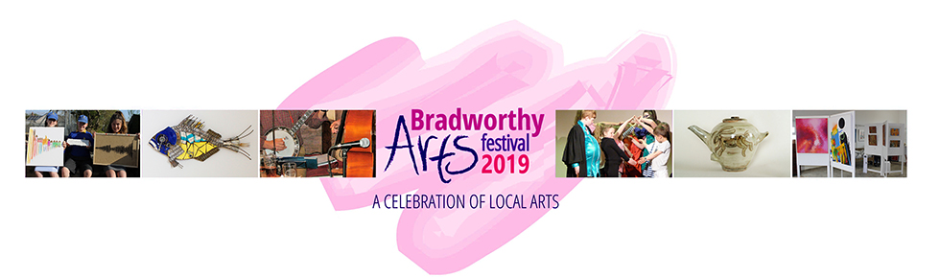
Dear Artist/Craftsmaker/Creative
As you have been a valued supporter/participant of the Bradworthy Arts Festival (BAF) in the past we would like to invite you to take part in the next festival, which will take place on May 4th and 5th, 2019.
The Bradworthy Arts Festival has undergone a few changes since the last event in May 2017. We have a few new members in our management team and a growing database of artists and craftspeople (please make it known to us if you wish to be removed from this database). The biggest change, however, is that the festival will now, for a variety of reasons, be held over two days instead of three.
As in the past each venue will “specialise" in particular media, although combinations of media-specific work within the same venue are still welcomed. As ever we are intending to feature crafts people in Bradworthy Memorial Hall and textiles people in the Methodist Chapel Room. The two-day event, in 2019, will be opened on Saturday, May 4th at 10.00am, so stall-holders should set up in advance of this time if possible. The opportunities for this are on Friday, May 3rd from 5.00pm until 9.00pm and early on the Saturday, from 08.00am to 10.00am (according to venue – please check the website for updates nearer the time). The cost for taking part in our next Festival will be £50 for the two days.
BAF has, in the past, been very well attended and we expect an increase in numbers in 2019, so if you are happy to be involved in 2019’s festival please be prepared with extra stock and all the equipment you might need for the two days – extension leads, lighting etc. Refreshments will, as usual, be available from village facilities plus food outlets in the village square.
Tables in the main hall (Memorial Hall) are approximately 6’x3’ and any one participant is allowed two (possibly three by negotiation the day). If you have any special requirements (e.g. access to plug sockets, chairs etc.) please state on the form attached to avoid disappointment at the event. Please make available a copy of your insurance certificate and make sure any electrical equipment you bring is PAT tested. Please state on the Registration Form what you need.
This is a two-day event so all exhibitors are expected to book for both days (unless by prior arrangement in special circumstances), arrange to have their tables supervised from 10.00am until 4.00pm each day and to provide (where appropriate) a workshop/demonstration/portfolio to engage people in their chosen media. If you have any problems on the day please see the Venue Officer who is there to help you. Please do not ask them to ‘man’ your table for any considerable length of time (other than an emergency) as they will be very busy when the venues are open to the public.
If you would like to be included/promoted on the BAF website please send Dave King your details and photos, images, statements etc. as soon as you can please to: davekingart@gmail.com. Other advertising will be in the form of the website, a 10,000 leaflet campaign, banners, social media and roadside signage.
Any questions or enquiries please ring 07472 928736
Forms must be sent to BAF by JANUARY 31ST 2019. (Dave King, The Chapel, Sutcombe, Devon EX22 7PN) or, better still, please email the form to bradworthyarts@btinternet.com

Many thanks from all the staff at BAF

