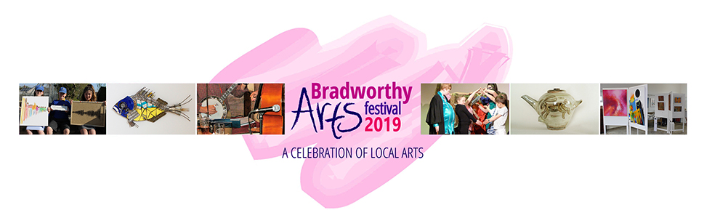
B.A.F. REGISTRATION FORM

Name:
Email: |  |  | Phone:
Address:

 |  |  | Postcode:
Trade name/website (if relevant):
BAF website inclusion (can we use you images and information on our website)? |  |  | YES / NO (please circle)
Proposed venue (please tick):
Bradworthy Hall (crafts and mixed media) □ | Bradworthy Chapel (Textiles work) □
If providing your own venue please give address if different from above:

Venue requirements
How many tables do you require?
Do you have any special requirements (electricity, water, chairs)?
Proposed activity for the festival if any (e.g. Exhibition, Demo, Talk, Workshop) and a brief description of what kind of product you are displaying/selling.

Do you have your own insurance? (please make a copy available if required)
Do you have a DBS (if necessary)? (please make a copy available if required)
Any electrical devices must have Portable Appliance Test (PAT) certificate (please provide a copy if required)
How would you like to pay? Cheque □ BACS □ PayPal □ (£50 for two day event)

Signature of applicant: |  |  |  | Date:
Cheques should be made payable to Bradworthy Arts Festival and must arrive with your completed form ASAP to secure your place but before January 31st, 2019.

All forms and cheques to be sent to BAF: Dave King, The Chapel, Sutcombe, Devon EX22 7PN
or (better still) email this form to bradworthyarts@btinternet.com

BACS transfer details and PayPal are available on the website registration page

This form and the information sheet are also available as a downloadable .docx word file on the registration page of our website: bradworthyartsfestival.co.uk/registration

